2. Your Overall Alignment Snapshot

What the LLM should produce
Maximum 3 sentences.

Sentence 1
Overall pattern.
Example:
Your results suggest a moderate level of overall alignment, with the strongest tensions emerging around role fit, authenticity, and sustained pressure.

Sentence 2
Explain the source.
Example:
The assessment indicates that these pressures are being driven less by workload itself and more by a mismatch between your natural way of operating and the demands of your current environment.

Sentence 3
Summarise consequence.
Example:
Over time, this pattern may create frustration, fatigue, or a sense that your contribution is not being expressed as effectively as it could be.

What the LLM Actually Needs
{
"overall_alignment": "Moderate",
"top_flags": [
"Structural Misfit",
"Authenticity Strain",
"Burnout Risk"
],
"interaction_summary": [
"Role-environment mismatch",
"Pressure to adapt",
"Sustained performance demand"
]
}
Everything else can be derived beforehand

My Recommendation
For Section 2 specifically, create a pre-processing step:
Assessment
↓
Scoring Engine
↓
Flag Scores
↓
Interaction Engine
↓
Summary Variables
↓
LLM
↓
3-Sentence Snapshot
The LLM should receive:

Required
- Overall Alignment Score
- Top 3 Flags
- Top 2 Interaction Insights

Optional
- Strongest contributing domain
Nothing more.
That will produce summaries that are:
- consistent,
- explainable,
- cheap to generate,
- and difficult for the model to "hallucinate."

3 Examples
Example 1
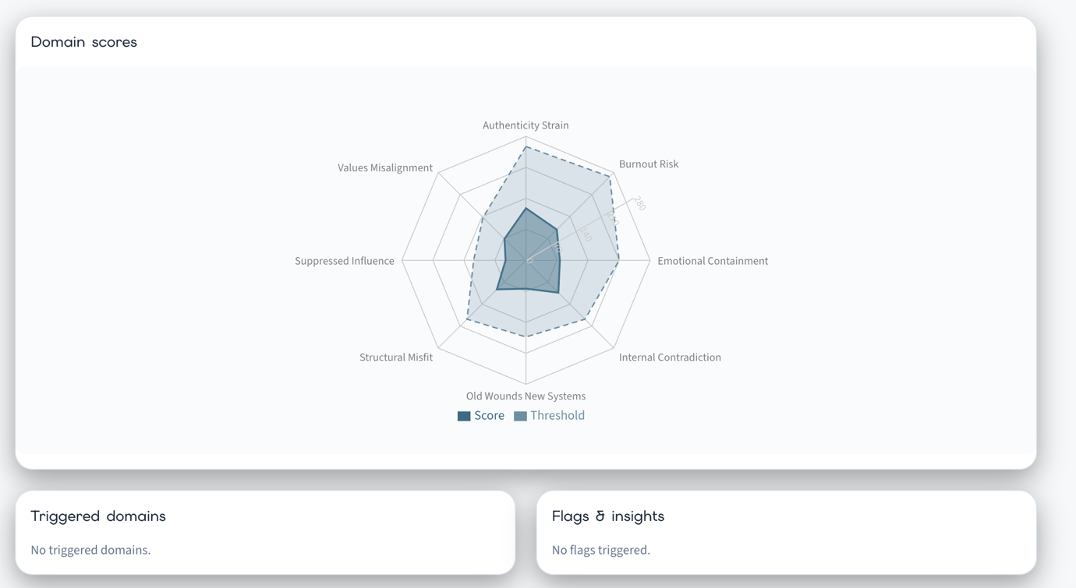

Overall Alignment Snapshot
Your assessment suggests a broadly balanced and well-aligned professional system. Although there are some areas where pressure and adaptation are present, these remain within manageable ranges and do not appear to be generating significant friction. Overall, your results indicate that your current role, environment, and personal drivers are working together relatively effectively.

Example 2
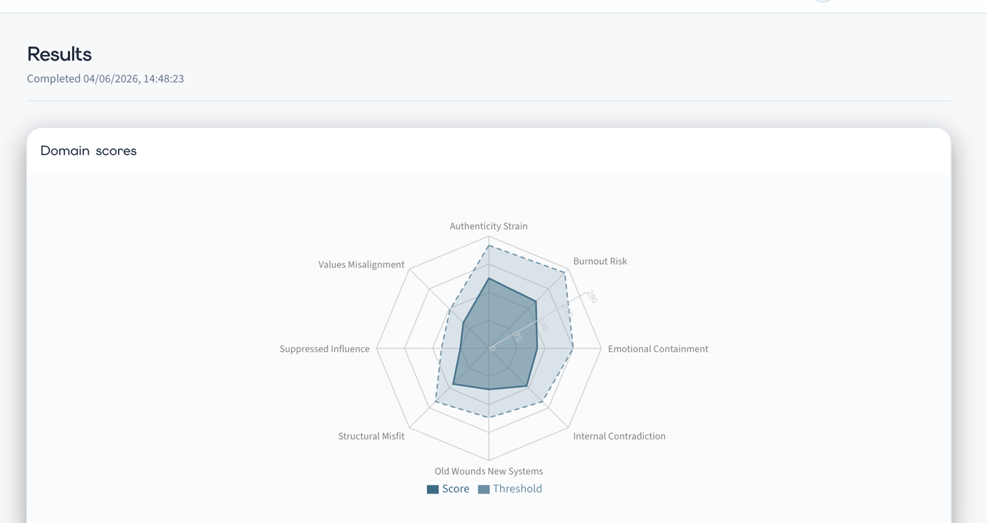

Overall Alignment Snapshot
Your results suggest a generally functional professional system, although there are emerging areas of strain that may warrant attention. The most prominent pattern relates to authenticity and adaptation, indicating that aspects of your environment may require you to operate in ways that do not feel entirely natural or sustainable. While these pressures are not currently severe, they may contribute to fatigue, frustration, or reduced engagement if maintained over extended periods.

Or a slightly more executive-style version:

Overall Alignment Snapshot
Your assessment indicates a moderate level of overall alignment, with the strongest pressures emerging around authenticity and sustained demand. This suggests that while your current role remains workable, there may be aspects of the environment that require ongoing adaptation or compromise. Over time, this pattern can place additional strain on energy, engagement, and long-term fit if not actively managed.

Example 3

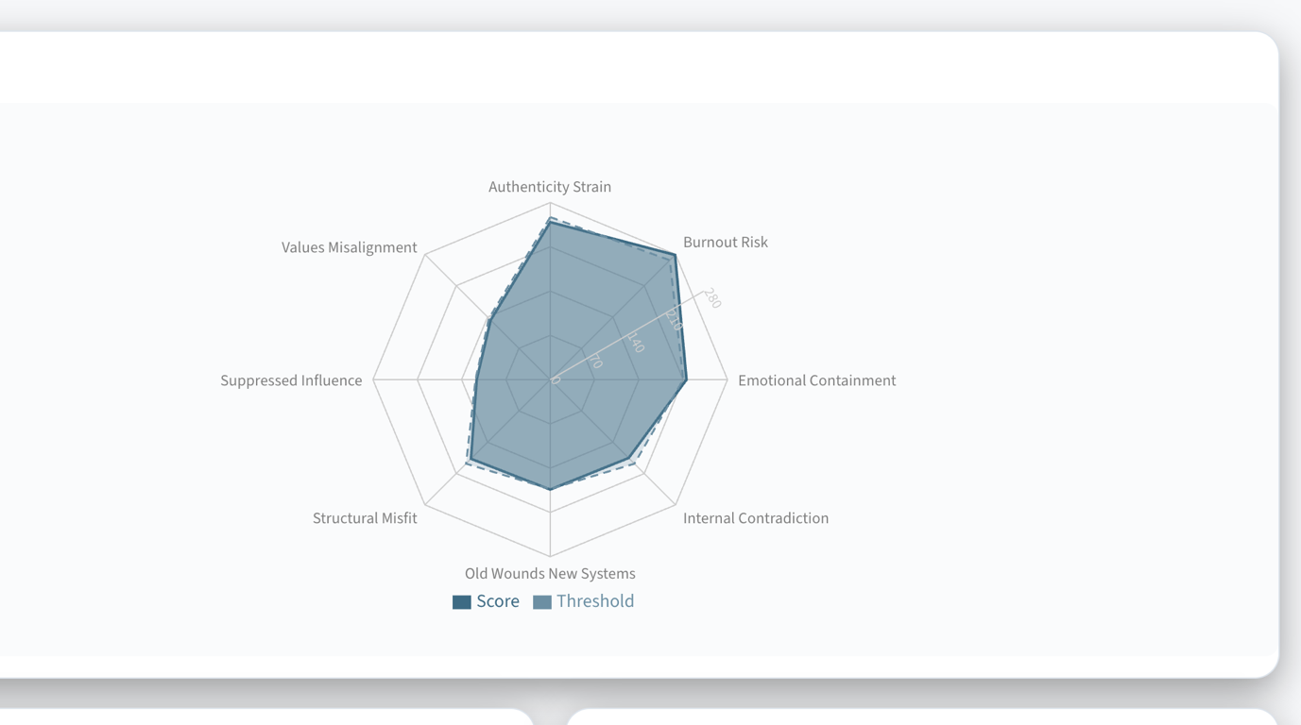

Overall Alignment Snapshot
Your assessment indicates a meaningful level of strain within your current professional system, with the strongest pressures emerging around authenticity and burnout risk. This suggests that sustaining your current role or environment may require ongoing adaptation that is becoming increasingly costly in terms of energy, engagement, or personal fit. While other areas remain relatively stable, the concentration of pressure within these domains indicates a pattern that is likely to become more difficult to sustain if left unaddressed.

What You Need to Build
Not paragraphs.
You need to build a relatively small set of interpretive variables.
Something like:

Overall System State
Stable
Emerging Strain
Meaningful Strain
Significant Misalignment

Primary Theme
Adaptation Pressure
Burnout Risk
Role Misfit
Suppressed Contribution
Values Conflict
Internal Conflict
Past Experiences Influencing Present Systems

Interaction Theme
Sustained adaptation is creating energy costs
Role demands are exceeding available resources
Meaning and role requirements are diverging
Insight is not translating into influence
Competing priorities are reducing clarity

Emotional Tone
Reassuring
Reflective
Concerned
Direct

Why This Works
Imagine two people:

Person A
High Burnout
High Authenticity
Theme:
Sustained adaptation is creating energy costs.

Person B
High Burnout
High Structural Misfit
Theme:
The demands of the role may not align with how you naturally operate.

The LLM can generate excellent summaries from those themes.
You don't need to write the final text.
You only need to tell the LLM:
What story is occurring.

For SUBAL Specifically
I think Section 2 could be generated from only 5 variables:
{
"overall_system_state": "...",
"primary_domain": "...",
"secondary_domain": "...",
"interaction_theme": "...",
"tone": "..."
}
That's it.
The LLM will reliably generate a good 3-sentence summary from that.

The place where I would invest effort is not writing hundreds of paragraphs. It's building the Interaction Theme Library.
In my view, that's the real intellectual property of SUBAL.
The scoring engine tells you:
What is happening.
The interaction themes tell you:
Why it feels the way it does.
And the LLM simply turns that into natural language.

